***JAYPEE INSTITUTE OF INFORMATION***

***TECHNOLOGY, NOIDA , SECTOR-62***

***PHYSICS-1 PROJECT***

***SYNOPSIS***

***Optical FIBER AND ITS PHYSICS***

***SUBMITTED TO:***

***Mr. ANIRBAN PATHAK sir***

***BY :***

***TEAM MEMBERS (B10 BATCH):***

* ***ARYAN RAZDAN (BJ61567)***
* ***HIMANSHU DIXIT (B64178)***
* ***MOHIT GARG(B63996)***

***abstract***

***content***

* ***Abstract………………………………..2***
* ***Introduction…………………………4***
* ***Important terms……………………..5***
* ***Application …………………..........7***
* ***Principle …………………………….11***
* ***Types of OF…………………….....12***
* ***Practical issues………………..….14***
* ***Observation………………………...16***
* ***Conclusion………………………....17***
* ***Acknowledgement…………….…18***
* ***References…………………………..19***

***introduction***

*Optical Fibers are used in communication instead of metal wires because signals travel along them with less loss, and they are also immune to electromagnetic interference. Fibers are also used for illumination, and are wrapped in bundles so they can be used to carry images, thus allowing viewing in tight spaces. Specially designed fibers are used for a variety of other applications, including sensors and fiber lasers. Light is kept in the core of the optical fiber by total internal reflection.*

*This causes the fiber to act as a waveguide. Fibers which support many propagation paths or transverse modes are called multi-mode fibers (MMF), while those which can only support a single mode are called single-mode fibers (SMF).*

*Multi-mode fibers generally have a larger core diameter, and are used for short-distance communication links and for applications where high power must be transmitted. Single-mode fiber are used for most communication links longer than 550 meters (1,800 ft).Joining lengths of optical fiber is more complex than joining electrical wire or cable. The ends of The fibers must be carefully cleaved, and then spliced together either mechanically or by fusing them together with an electric arc.*

***Important terms***

* ***Optical Fiber:*** *An optical fiber (or fibre) is a glass or plastic fiber that carries light along its length. Optical fibers are widely used in fiber-optic communications, which permits transmission over longer distances and at higher bandwidths (data rates) than other forms of communications.*
* ***Refraction:*** *Refraction is the change in direction of a wave due to a change in its speed. This is most commonly observed when a wave passes from one medium to another.*
* ***Reflection:*** *Reflection is the change in direction of a wave front at an interface between two different media so that the wave front returns into the medium from which it originated. Common examples include the reflection of light, sound and water waves.*
* ***Scattering:*** *Scattering is a general physical process where some forms of radiation, such as light, sound, or moving particles, are forced to deviate from a straight trajectory by one or more localized non-uniformities in the medium through which they pass.*
* ***Total Internal Reflection:*** *Total internal reflection is an optical phenomenon that happens when aray of light strikes a medium boundary at an angle larger than a particular critical angle with respect to the normal to the surface. If the refractive index is lower on the other side of the boundary and the incident angle is greater than the critical angle, no light can pass through and all of the light is reflected.*

***Its application***

* ***Optical fibre communication:***

*Optical fiber can be used as a medium for telecommunication and networking because it is flexible and can be bundled as cables. It is especially advantageous for long-distance communications, because light propagates through the fiber with little attenuation compared to electrical cables. This allows long distances to be spanned with few repeaters.*

*Additionally, the per-channel light signals propagating in the fiber can be modulated at rates as high as 111 gigabits per second, although 10 or 40 Gb/s is typical in deployed systems. Each fiber can carry many independent channels, each using a different wavelength of light (wavelength-division multiplexing (WDM)).*

*For short distance applications, such as creating a network within an office building, fiber-optic cabling can be used to save space in cable ducts.This is because a single fiber can often carry much more data than many electrical cables. Fiber is also immune to electrical interference; there is no cross-talk between signals Although fibers can be made out of transparent plastic, glass, or a combination of the two, the fibers used in long-distance telecommunication applications are always glass, because of the lower optical attenuation. Both multi-mode and single-mode fibers are used in communications, with multi-mode fiber used mostly for short distances, up to 550m (600 yards), and single-mode fiber used for longer distance links. Because of the tighter tolerances required to couple light into and between single-mode fibers (core diameter about 10 micrometers),single-mode transmitters, receivers, amplifiers and other components are generally more expensive than multi-mode components.*

* ***Fiber optic sensors:***

*Fibers have many uses in remote sensing. In some applications, the sensor is itself an optical fiber. In other cases, fiber is used to connect a**non-fiber optic sensor to a measurement system. Depending on the application, fiber may be used because of its small size, or the fact that no electrical power is needed at the remote location, or because many sensors can be multiplexed along the lengthof a fiber by using different wavelengths of light for each sensor, or by sensing the time delay as light passes along the fiber**through each sensor.**Optical fibers can be used as sensors to measure strain, temperature ,pressure and other quantities by modifying a fiber so that the quantity to be measured modulates the intensity, phase, polarization, wavelength or transit time of light in the fiber. Sensors that vary the intensity of light are the simplest, since only a simple source and detector are required. A particularly useful feature of such fiber optic sensors is that they can, if**required, provide distributed sensing over distances of up to one meter.Extrinsic fiber optic sensors use an optical fiber cable, normally a multi-mode one, to**transmit modulated light from either a**non-fiber optical sensor, or an electronic sensor connected to an optical transmitter. A major benefit of extrinsic sensors is their ability to reach places which are otherwise inaccessible. An example is the measurement of temperature inside aircraft jet engines by using a fiber to transmit radiation into a radiation pyrometer located outside the engine.Extrinsic sensors can also be used**in the same way to measure the internal temperature of electrical transformers, where the extreme electromagnetic fields present make other measurement techniques impossible. Extrinsic sensors are used to measure vibration, rotation, displacement, velocity,**acceleration, torque ,and twisting.*

* ***Other uses of optical fibers:***

*Fibers are widely used in illumination applications. They**are used as light guides in medical and other applications where bright light needs to be shone on a target without a clear line-of-sight path. In some buildings, optical fibers are used to route sunlight from the roof to other parts of the building (see non-imaging optics). Optical fiber illumination is also used for decorative applications, including signs, art, and artificial Christmas trees. Swarovski boutiques use optical fibers to illuminate their crystal showcases from many different angles while only employing one light source .Optical fiber is also used in imaging optics. A coherent bundle of fibers is used, sometimes along with lenses, for a long, thin imaging device called an endoscope, which is used to view objects through a small hole. Medical endoscopes are used for minimally invasive exploratory or surgical procedures (endoscopy).Industrial endoscopes (see fiberscope or bore scope) are used for inspecting anything hard to reach, such as jet engine interiors. In spectroscopy, optical fiber bundles are used to transmit light from a spectrometer to a substance which cannot be placed inside the spectrometer**itself, in order to**analyze its composition. A spectrometer analyzes substances by bouncing light offof and through them. By using fibers, a spectrometercan be used to study objects that are too large to fit inside, or gasses, or reactions which occur in pressure vessels. Optical fiber can be used to supply a low**level of power (around one watt) to electronics situated in a difficult electrical environment .Examples of this are electronics in high-powered antenna elements and measurement devices used in high voltage transmission equipment.*

***Principle of operation***

*An optical fiber is a cylindrical dielectric waveguide (non conducting waveguide) that transmits light along its axis, by the process of total internal reflection. The fiber core is surrounded by a cladding layer.*

***Types of optical fiber***

* ***Single Mode Fiber***

*Fiber supporting only one mode is called single-mode or mono-mode fiber. The behaviour of larger-core multi-mode fiber can also be modeled using thewave equation, which shows that such fiber supports more than one mode of propagation (hence the name). The results of such modeling of multi-mode fiber approximately agree with the predictions of geometric optics,if the fiber core is large enough to support more than a few modes.*

* ***Multi Mode Fiber***

*In a multi-mode**fiber, rays of light are guided along the fiber core by total internal reflection. Rays that meet the**core-cladding boundary at a**high angle (measured relative to a line normal to the boundary), greater than the critical angle for this boundary, are completely reflected. The critical angle (minimum angle for total internal reflection) is determined by the difference in index of refraction between the core and cladding materials.Rays that meet the boundary at a low angle are refracted from the core into the cladding, and do not convey light and hence information along the fiber. The critical angle determines the acceptance angle of the fiber ,often reported as a numerical aperture. A high numerical aperture allows light to propagate down the fiber in rays both close to the axis and at various angles, allowing efficient coupling of light into the fiber.However, this high numerical aperture increases the amount of dispersion as rays at different angles have different path lengths and therefore take different times to traverse the fiber*

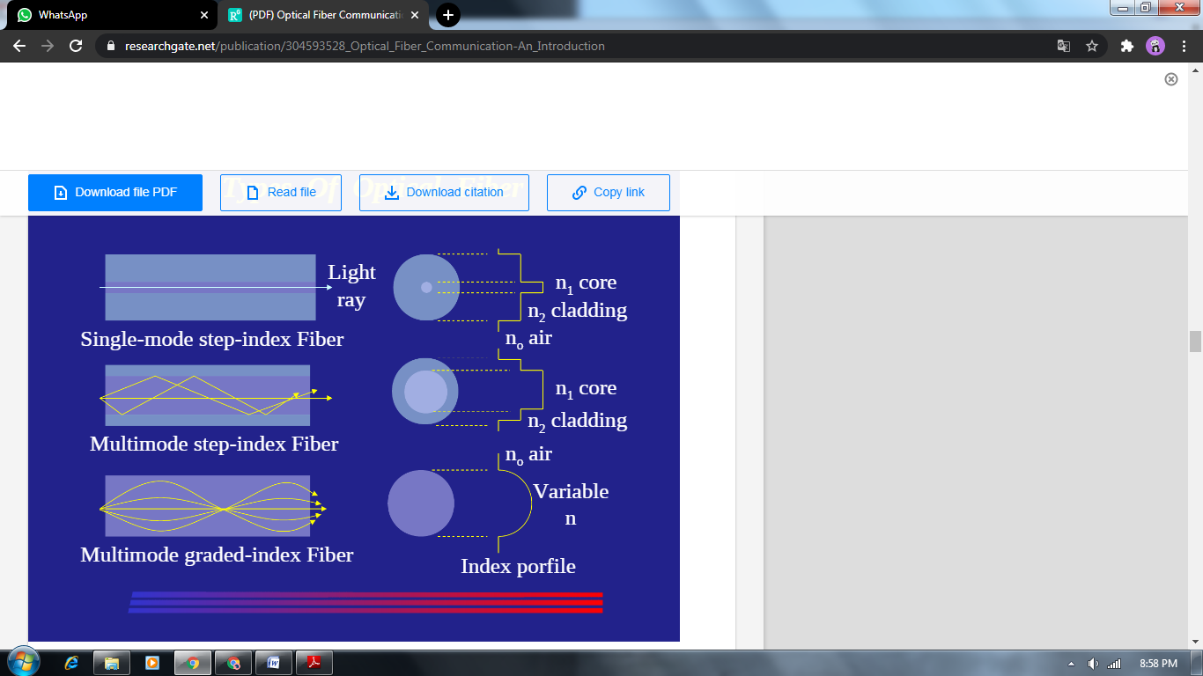

[*https://www.researchgate.net/publication/304593528_Optical_Fiber_Communication-An_Introduction*](https://www.researchgate.net/publication/304593528_Optical_Fiber_Communication-An_Introduction)

***Problems or practical issues***

*In practical fibers, the cladding is usually coated with a tough resin buffer layer,which may be further surrounded by a jacket*

*layer, usually plastic. These layers add strength to the fiber but do not contribute to its optical wave guide properties.*

*Rigid fiber assemblies sometimes put light-absorbing ("dark") glass between the fibers, to prevent light that leaks out of one fiber from entering another. This reduces cross-talk between the fibers, or reduces flare in fiber bundle imaging applications.*

*Modern cables come in a wide variety of sheathings and armor, designed for applications such as direct burial in trenches, high voltage isolation, and dual use as power lines, and installation in conduit, lashing to aerial telephone poles,submarine installation, and insertion in paved streets. The cost of small fiber-count pole-mounted cables has greatly decreased due to the high Japanese and South Korean demand for*

*fiber to the hom (FTTH) installations.*

*Fiber cable can be very flexible, but traditional fiber's loss increases greatly if the fiber is bent with a radius smaller than around 30 mm. This creates a problem when the cable is bent around corners or wound around a spool, making FTTX*

*installations more complicated. "Bendable fibers", targeted towards easier installation in home environments, have been standardized as ITU-T G.657. This type of fiber can be bent with a radius as low as 7.5mm without adverse impact.*

*Even more bendable fibers have been developed. Bendable fiber may also be resistant to fiber hacking, in which the signal in a fiber is surreptitiously monitored by bending the fiber and detecting the leakage.*

***OBSERVATION***

*From the project we oberve that optical fibre is mainly used communication system. Optical fiber Communication System is a system with light as the carrier and fiber as the*

*communication medium.Instead of using an electrical signal traveling over a cable or electromagnetic waves traveling*

*through space, the information is put on a light beam and transmitted through space or through a special cable. But, lower the distance or length of optic fiber system is better for*

*BER, quality factor and so on.*

***coNCLUSION***

*Optical fiber technology has been used in many areas of*

*telecommunication, photonics, medical and engineering.It has attracted many researchers due to its performance, low loss, no interference, higher bandwidth and its inherently high data-carrying capacity. Although optical fibers have many advantages, there still exist some disadvantages associated with the optical fiber technology. One of the disadvantages of the optical fibers is that in spite of the natural abundance of the*

*material for optical fiber construction which is the sand, the fibers are more expensive compared to copper cables. Another disadvantage is that; high-skilled manpower is needed for optical fiber mounting.*

***ACKNOWLEDGEMENT***

*We extend our sincere thanks to* ***Jaypee Institute of Information and Technology*** *which provided us with the opportunity to make the project.The project could have never been possible without the support of various sources and my team. It is extremely impossible to thank every individual who has helped me in completing this project. Some people have helped in the basic formularization and there were sources that helped me in giving the ideas a physical form/ shape .I am extremely grateful to my mentor, Mr ANIRBAN PATHAK , and my team mate for his support and guidance in the project right from the beginning. My team vital support helped the project to take a logical and suitable shape. We take this opportunity to thank the College authorities, for extending their full support and cooperation in the project.*

*Last but not the least; I would like to thank everyone who has offered a helping hand when required.*

*ARYAN RAZDAN , HIMANSHU DIXIT , MOHIT GARG*

***(BJ61567) (B64178) (B63996)***

***REFERENCES***

* *Engineering physics book by Ajoy Ghatak*
* *Image courtesy*
* *www.google.com*
* *www.wikipedia.org*
* *www.youtube.com*
* *www.thefoa.org*
* *www.slideshare.net*
* *https://pdfcoffee.com*

***WORK DONE BY EACH MEMBER***

1. ***Aryan Razdan.***

***Help our team by choosing the topic and introduction,abstract ,and conclusion of the project.***

1. ***Himanshu Dixit.***

***Help our team by detail search of topic by books and google from its application to principle of optical fiber.***

1. ***Mohit Garg.***

***Help our team by observing the project and topic and give important terms***